Year 10
General

Test 4

2019


Name: ______________________ Class: ______ Time: 40 minutes Total Mark:____/36

Show working and answers on this sheet. Show working in sufficient detail to support your answers. Incorrect answers without supporting reasoning will be allocated zero marks.

Resources: 1 A4 page of notes (1 side), Calculator allowed.

Question 1 5 marks

Plot the following linear graphs for the given range of $x$ – values on the same Cartesian plane:
a) | $$y=x+2$$ | b) | $$y=2x$$
 | $$x$$ 0 1 2 3  $$y$$ |  | $$x$$ 0 1 2 3  $$y$$

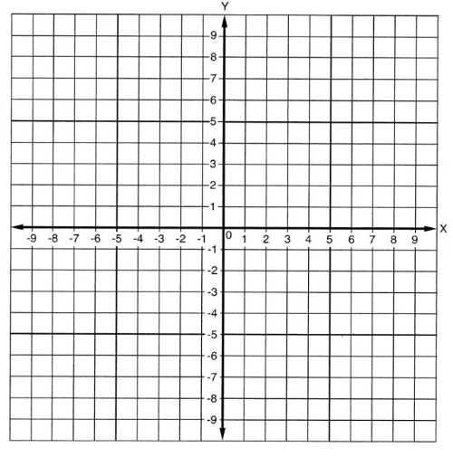
c) Use these graphs to determine the point of intersection and, hence, the solution of the simultaneous equations.

Question 2 2 marks

Use the graphs below of the given simultaneous equations to write the point of intersection and, hence, the solution of the simultaneous equation.
Equation 1: $x-y=1$
Equation 2: $x+y=3$
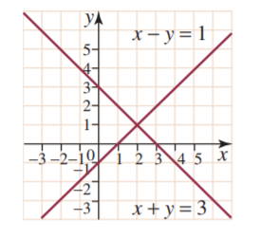
Question 3 5 marks

Solve the following pair of simulations equations using a graphical method
  - $y=2x+3$
  - $y=\frac{1}{2}x+1$



  - Use these graphs to determine the point of intersection and, hence, the solution of the simultaneous equations.

Question 4 10 marks

Solve each of the following equations (that is, find the value for the pronumeral that makes each statement true).
a) | $$x+2=8$$ | b) | $$6k=36$$
c) | $$\frac{w}{5}=-9$$ | d) | $$5a+6=26$$
e) | $$\frac{f}{4}+6=16$$ | f) | $$\frac{x}{2}- \frac{3x}{5}=\frac{1}{4}$$

Question 5 4 marks

Find the gradient of each of the following pairs of lines and determine if they are perpendicular or parallel.
- $y=2x+5 and y=2x+6$

Gradients: Are these lines parallel/perpendicular (circle the correct answer)

- $y=\frac{1}{3}x+1 and y=-3x+2$

Gradients: Are these lines parallel/perpendicular (circle the correct answer)

Question 6 6 marks

Solve the following pair of simultaneous equations using an algebraic method:
$$y=2x$$
$x+ y$=18

Question 7 4 marks

Look at the 5 equations below
- $y=3x+3$
- $3x+y=3$
- $3x-y=3$
- $3x+3y=2$
- $3y=x+3$

- Which two of the lines are parallel? | - Which two of the lines are perpendicular?
END OF TEST

